Pathways diagrams now show reactome stable identifiers.
Pathway 229: The canonical retinoid cycle in rods
The classifier can achieve 80% accuracy on this pathway between SCC and AC types of cancer.
REACT_160072: atROL binds RBP1 to form RBP1:atROL
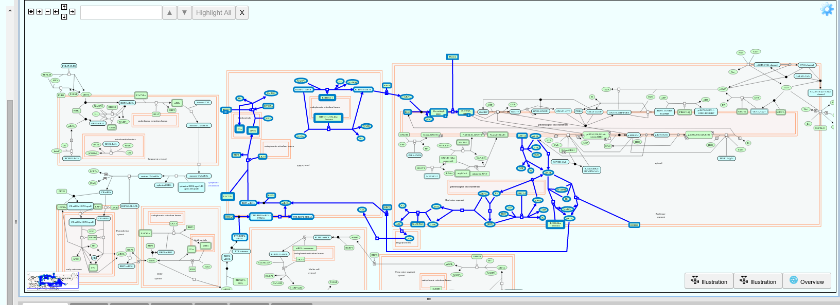

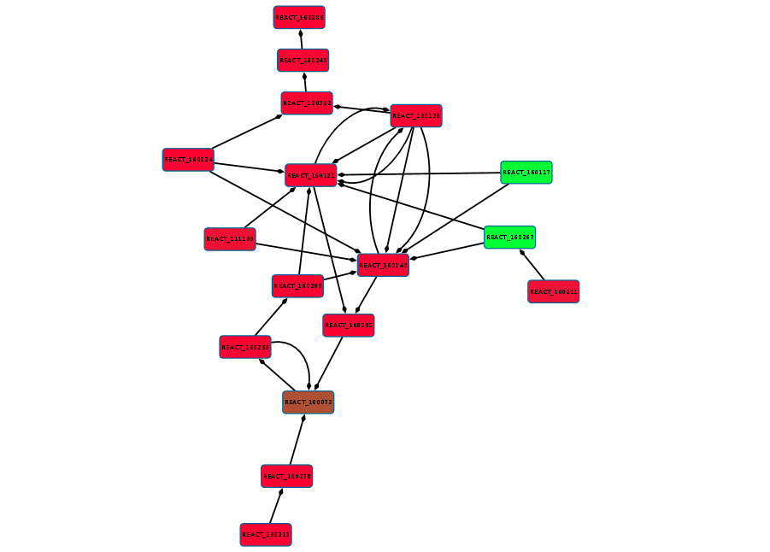
Pathway 229 ac aggregate.

Pathway 229 scc aggregate
